**Prasanna Dhungana**

**21053439**

**A-28**

**LAB Assignment 10**

**1. Write a C Program to find out the value of for given integer values of n and**

**r (user inputs) by using a user defined function for factorial.**

***Program:***

**#include<stdio.h>**

**int fact(int);**

**int main(){**

**int num , n, r , r1 , nr , nr1 , ncr;**

**printf("Enter the value of n and r =");**

**scanf("%d %d",&num , &r );**

**if (num>=r && num>=0 && r>=0){**

**n= fact(num);**

**r1 = fact(r);**

**nr = num-r;**

**nr1 = fact(nr);**

**ncr = n /(nr1 *r1);**

**printf("%d C %d = %d",num, r, ncr );**

**}**

**else{**

**printf("invalid Value");**

**}**

**}**

**int fact(int a){**

**int f=1,i;**

**if ( a == 0 || a == 1){**

**return f;**

**}**

**else{**

**for (i=2; i<=a ; i++ ){**

**f *= i;**

**}**

**}**

**return f;**

**}**

***OUTPUT:***

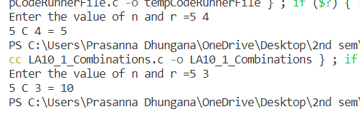

**2. Write a C Program to find out the sum of digits of a given integer number n**

**by defining and using a C function.**

***Program:-***

**#include<stdio.h>**

**int sum(int);**

**int main(){**

**int num ,s;**

**printf("\n\nEnter the number = ");**

**scanf("%d",&num);**

**printf("The sum of the digits of the number is : %d\n\n",sum(num));**

**}**

**int sum(int a){**

**int su = 0 ,r ;**

**while (a != 0){**

**r = a % 10;**

**su += r;**

**a = a / 10;**

**}**

**return su;**

**}**

***OUTPUT:-***

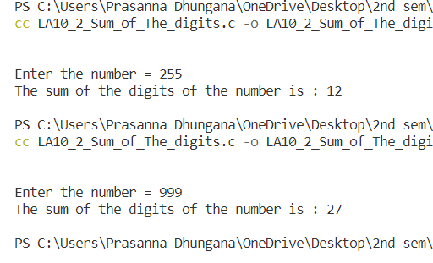

**3. Write a C Program to test whether a given integer number n is a**

**palindrome number or not.**

***Program:-***

**#include<stdio.h>**

**void palindrome(int);**

**int main(){**

**int num ,s;**

**printf("\n\nEnter any integer to check whether it is a palindrome or not = ");**

**scanf("%d",&num);**

**palindrome(num);**

**return 0;**

**}**

**void palindrome(int a){**

**int r , pl=0 , o;**

**o = a;**

**while (a != 0){**

**r = a % 10;**

**pl= (pl * 10) + r;**

**a = a / 10;**

**}**

**if (pl == o){**

**printf("It is a palindrome.\n\n");**

**}**

**else{**

**printf("It is not a palindrome.\n\n ");**

**}**

**return ;**

**}**

**Output:-**

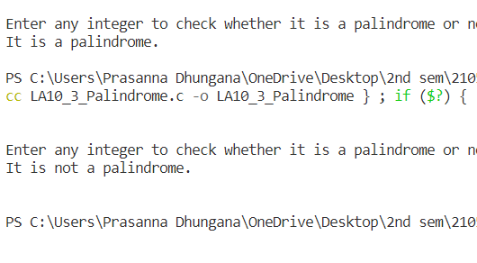

**4. Write a C Program to calculate the value of x y for any given real number x**

**and any integer number y by writing a suitable function for the same.**

***Program:-***

**#include<stdio.h>**

**double power(double , int);**

**int main(){**

**double x ,pw ;**

**int n;**

**printf("\n\nEnter any two numbers to find the the X^Y = ");**

**scanf("%lf %d",&x,&n);**

**pw = power(x ,n);**

**printf("%.3lf ^ %d = %.3lf\n\n", x , n , pw);**

**return 0;**

**}**

**double power(double a,int b){**

**int i ;**

**double p=1;**

**for (i = 0 ; i < b ; i++){**

**p =(float) p * a;**

**}**

**return p;**

**}**

***Output:-***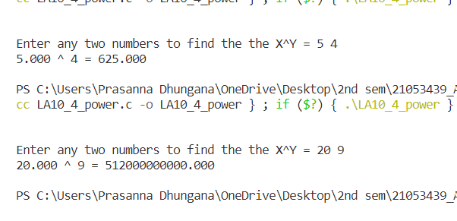

**5. Write a C Program to generate all the prime numbers between 1 and n (a**

**value supplied by the user). Use a user-defined function isPRIME(x) that**

**can test whether the input x is prime number or not.**

***Program:-***

**#include <stdio.h>**

**int isPRIME(int);**

**int main(){**

**int num , i ,j , B ;**

**printf("\n\nEnter a integer upto which program checks the prime : ");**

**scanf("%d",&num);**

**if (num>=2){**

**for (i = 2 ; i<=num ; i++ ){**

**B = isPRIME(i);**

**if (B == 1){**

**printf("%d ",i);**

**}**

**}**

**printf("\n\n");**

**}**

**else {**

**printf("invalid input!! your input was %d, Try other values",num);**

**}**

**}**

**int isPRIME(int a){**

**int flag = 1 , j ;**

**for (j=2 ; j < a; j++){**

**if (a % j ==0){**

**flag = 0;**

**break;**

**}**

**}**

**return flag;**

**}**

***Output:-***

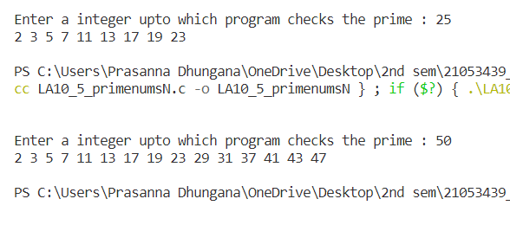

**6. Write a C Program to compute the sine series using the following function**

**representation:**

**sin(x) = x - x 3 /3! + x 5 /5! - x 7 /7! + ……..**

***Program:-***

**#include<stdio.h>**

**int factorial(int);**

**double power(double, int);**

**int main(){**

**int n ,y , f , i ;**

**signed int sign;**

**double num , pw, sum , deg = 0 ;**

**printf("\n\nEnter the value of X in sin(X) in degrees and upto which term to iterate the series of sinx :");**

**scanf("%lf %d",&deg ,&n);**

**num = ((deg*3.14)/180);**

**for (i =0 ; i<n ; i++){**

**y= (2*i)+1;**

**pw= power(num ,y );**

**f = factorial(y);**

**sign = power(-1,i);**

**sum = sum + ((sign * pw)/f);**

**}**

**printf("The value from the series is : %.3lf\n\n",sum);**

**}**

**double power(double a,int b){**

**int i ;**

**double p=1;**

**for (i = 0 ; i < b ; i++){**

**p =(float )p * a;**

**}**

**return p;**

**}**

**int factorial(int a){**

**int f=1,i;**

**if ( a == 0 || a == 1){**

**return f;**

**}**

**else{**

**for (i=2; i<=a ; i++ ){**

**f *= i;**

**}**

**}**

**return f;**

**}**

**Output:**

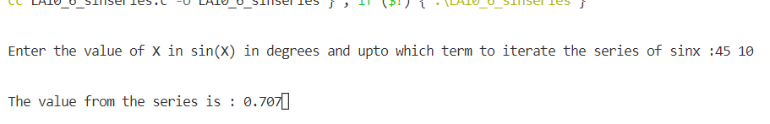

**7. Write a C Program to compute the cosine series using the following**

**function representation:**

**cos(x) = 1 - x 2 /2! + x 4 /4! - x 6 /6! + ……..**

***Program:***

**#include<stdio.h>**

**int factorial(int);**

**double power(double, int);**

**int main(){**

**int n ,y , f , i ;**

**signed int sign;**

**double num , pw, sum = 0 ,deg;**

**printf("Enter the value of X in cos(X) in degrees and upto which term to iterate the series of cos(x): ");**

**scanf("%lf %d",&deg ,&n);**

**num = ((deg*3.14)/180);**

**for (i =0 ; i<n ; i++){**

**y= 2*i;**

**pw= power(num ,y );**

**f = factorial(y);**

**sign = power(-1,i);**

**sum = sum + ((sign * pw)/f);**

**}**

**printf("The value from the series is : %.3lf",sum);**

**}**

**double power(double a,int b){**

**int i ;**

**double p=1;**

**for (i = 0 ; i < b ; i++){**

**p =(float )p * a;**

**}**

**return p;**

**}**

**int factorial(int a){**

**int f=1,i;**

**if ( a == 0 || a == 1){**

**return f;**

**}**

**else{**

**for (i=2; i<=a ; i++ ){**

**f *= i;**

**}**

**}**

**return f;**

**}**

***Output:***



**8. Write a C Program to compute the power series (e to the power x) using the**

**following function representation:**

**e^x = 1 + x + x 2 /2! + x 3 /3! + x 4 /4! + ………..**

***Program:-***

**#include<stdio.h>**

**int factorial(int);**

**double power(double, int);**

**int main(){**

**int n ,y , f , i ;**

**double num , pw, sum = 0 , sign;**

**printf("\n\nEnter the value of X in e^x and upto which term to iterate the series of e^x: ");**

**scanf("%lf %d",&num ,&n);**

**for (i =0 ; i<n ; i++){**

**pw= power(num ,i );**

**f = factorial(i);**

**sum = sum + ( pw/f);**

**}**

**printf("The value from the series is : %lf\n\n",sum);**

**}**

**double power(double a,int b){**

**int i ;**

**double p=1;**

**for (i = 0 ; i < b ; i++){**

**p =(float )p * a;**

**}**

**return p;**

**}**

**int factorial(int a){**

**int f=1,i;**

**if ( a == 0 || a == 1){**

**return f;**

**}**

**else{**

**for (i=2; i<=a ; i++ ){**

**f *= i;**

**}**

**}**

**return f;**

**}**

**Program:**

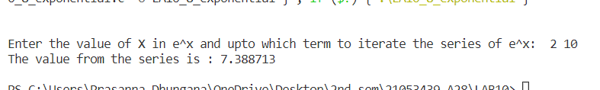

**9. Write a C Program to find the LCM of two numbers a and b by using a**

**suitable function.**

***Program:***

**#include<stdio.h>**

**int GCD(int,int);**

**int main(){**

**int num1 , num2, LCM ;**

**printf("\n\nEnter any two numbers:");**

**scanf("%d %d",&num1 , &num2);**

**LCM = (num1 * num2)/(GCD(num1,num2));**

**printf("The LCM of numbers %d and %d is = %d\n\n",num1,num2,LCM);**

**return 0;**

**}**

**int GCD(int a ,int b){**

**int i, g , c;**

**c=b;**

**if (a<b){**

**c = a;**

**}**

**for (i =1 ; i<=c ; i++){**

**if ((a % i == 0) && (b % i == 0))**

**g=i;**

**}**

**return g;**

**}**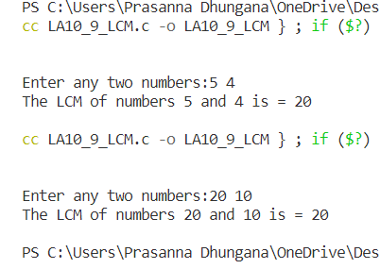

***Output:-***